**Classroom Activity: Apply styling on the portfolio website to improve the look and feel.**

**Code: (Style.css)**

|  |
| --- |
| body {      font-family: Arial, sans-serif;      margin: 0;      padding: 0;      box-sizing: border-box;    }    header {      background-color: lightseagreen;      color: black;      padding: 10px 0;      text-align: center;    }    h2::before {      content: "😊 ";      color: green;  }  p::first-line {    font-weight: bold;    color: blue;  }  p::first-letter {    font-size: 2em;    color: red;  }  blockquote::selection {    background-color: yellow;    color: black;  }  h3::after {    content: " 💻";    color: red;  }    nav ul {      list-style: none;      padding: 0;    }    .projects-grid {      display: grid;      grid-template-columns: repeat(auto-fill, minmax(300px, 1fr));      gap: 1rem;      transition: transform 0.3s ease, background-color 0.3s ease;    }    .projects-grid:hover{      transform: scale(1.2) rotate(10deg);      background-color: coral;    }    .project {      border: 1px solid #ddd;      padding: 1rem;      border-radius: 8px;      background-color: #f9f9f9;      display: flex;      flex-direction: column;      align-items: center;    }      .project img {      margin-bottom: 1rem;    }      nav ul li {      display: inline;      margin: 0 10px;    }      nav ul li a {      color: black;      text-decoration: none;    }      section {      padding: 20px;      display: flex;      flex-wrap: wrap;      justify-content: space-between;    }      article, aside, figure, form, table, blockquote {      margin: 20px 0;    }      figure img {      max-width: 100%;       grid-row: auto;      grid-column: auto;      }      table {      width: 100%;      border-collapse: collapse;    }      table th, table td {      border: 1px solid black;      padding: 8px;    }      tfoot td {      font-weight: bold;      text-align: center;    }      video {      width: 100%;      max-width: 600px;    }      form {      display: flex;      flex-direction: column;    }      form label {      margin-top: 10px;    }      form textarea {      resize: vertical;    }      blockquote {      border-left: 4px solid blue;      padding-left: 10px;      margin: 20px 0;      font-style: italic;    }      footer {      background: lightseagreen;      color: black;      text-align: center;      padding: 10px 0;      position: fixed;      bottom: 0;      width: 100%;    }    footer::before {      content: "🖱️"; /* Smiley emoji */      color: green;  }      @media (max-width: 768px) {      nav ul li {          display: block;          margin: 5px 0;      }        section {          flex-direction: column;      }        video {          max-width: 100%;      }    } |

**Output:**

**Home Page:**

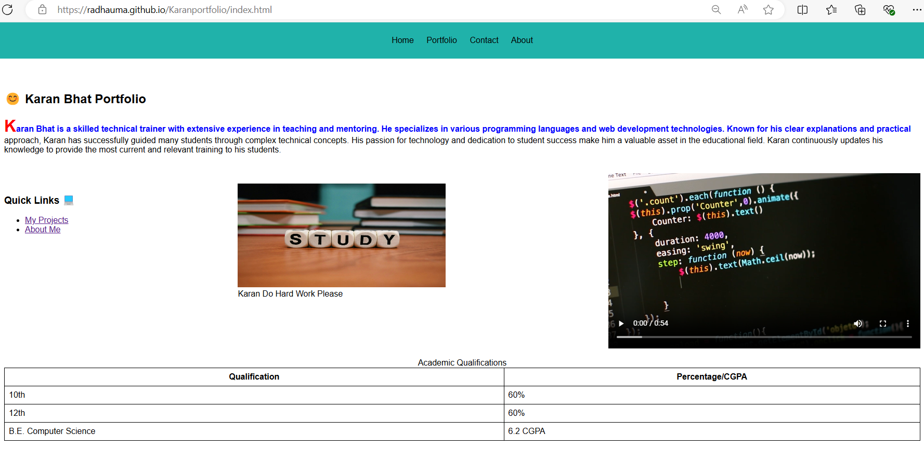

**Portfolio Page:**

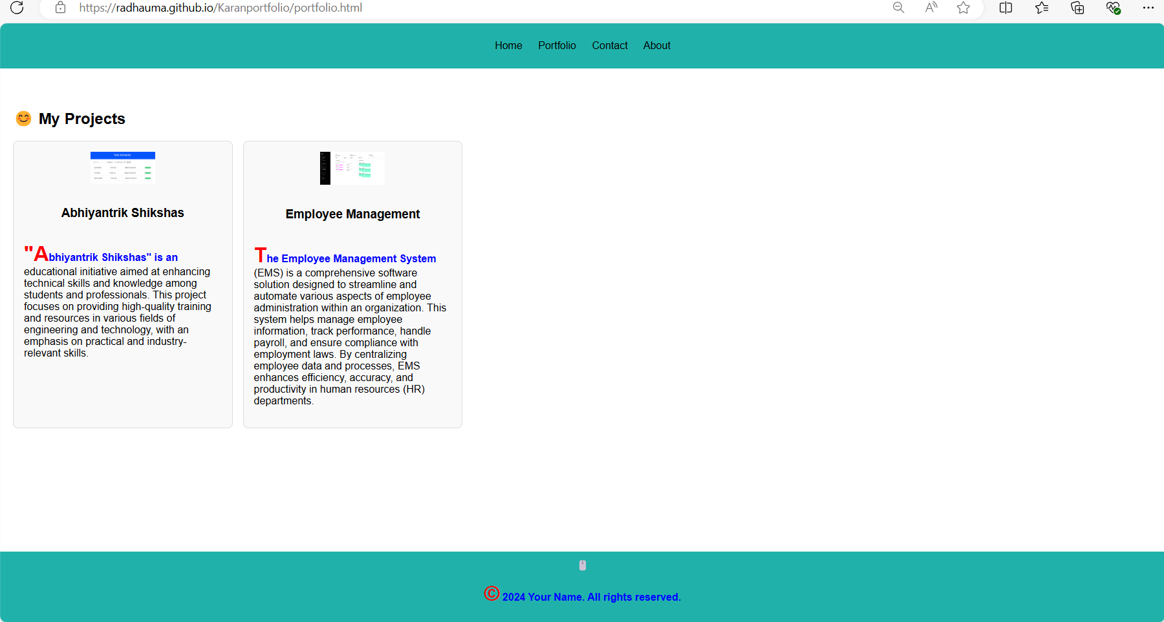

**Contact Page:**

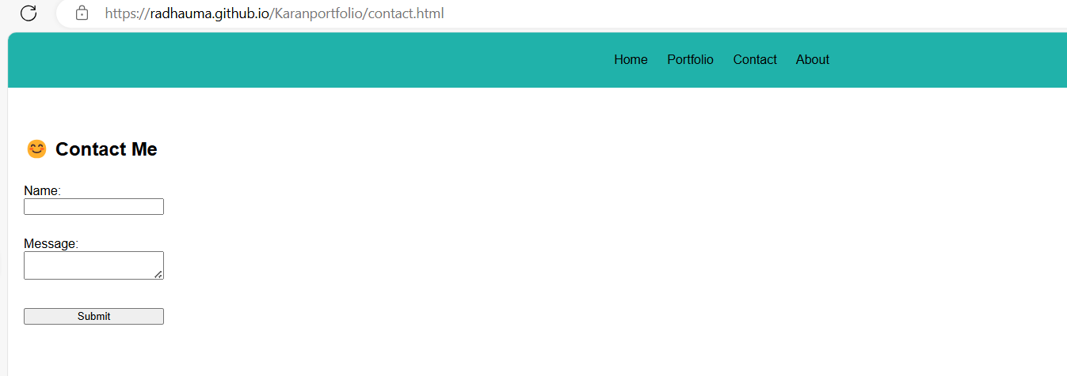

**About Page:**

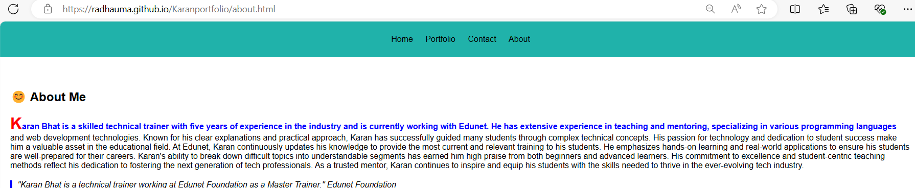

**Execution Steps:**

* Step 1: Set Up Your Project Directory
* Open Visual Studio Code.
* Create a new folder for your project, e.g., PortfolioProject.
* Step 2: Create the file name eg.)style.css
* Write a code to style a website.
* Step 3: Click on Go Live.
* Step 4: Then it automatically takes up to the browser page.
* Step 5: Select Inspect
* Step 6: Get the idea of the code.